HD Analog Digital Video Recorder

CJ-HDR216

16 CH HDCVI 2 SATA HDD Analog Digital Video Recorder
illuminator

Model |  |  | CJ-HDR216
Video/ Audio IF
Video Input |  |  | 16 CH, BNC
Type |  | HDCVI | 720p/ 1080p HDCVI
 |  | Analog | NTSC/ PAL
Video Output |  |  | 1 HDMI, 1 VGA
Audio Input |  |  | 1 CH, RCA
Audio Output |  |  | 1 CH, RCA
Two-way Talk |  |  | Reuse audio input/ output CH 1
Display
Output Resolution |  |  | 1920×1080, 1280×1024, 1280×720, 1024×768
Multiscreen Mode |  |  | 1/4/8/9/16
Privacy Masking |  |  | 4 rectangular zones (each camera)
OSD |  |  | Camera title, Time, Video loss, Camera lock, Motion detection, Recording
Video/ Audio Format
Video/Audio Compression |  |  | H.264/ G.711
Record Rate | Main Stream |  | 1080P (1~15fps)/ 720P/ 960H/ D1 (1~25/30fps)
 | Extra Stream |  | CIF/ QCIF (1~25/30fps), D1 (1~12/15fps)
Bit Rate |  |  | 96~4096Kb/s
Record Mode |  |  | Manual, Schedule (Regular (Continuous), MD), Stop
Record Interval |  |  | 1~60 min (default: 60 min), Pre-record: 1~30 sec, Post-record: 10~300 sec
Alarm/ Event
Trigger Events |  |  | Recording, PTZ, Tour, Video Push, Email, FTP, Snapshot, Buzzer & Screen tips
Video Detection |  |  | Motion Detection, MD Zones: 396 (22×18), Video Loss & Camera Blank
Playback & Backup
Sync Playback |  |  | 1/4/9/16
Search Mode |  |  | Time/Date, MD & Exact search (accurate to second)
Playback Functions |  |  | Play, Pause, Stop, Rewind, Fast play, Slow play, Next file, Previous file, Next camera, Previous camera, Full screen, Repeat, Shuffle, Backup selection, Digital zoom
Backup Mode |  |  | USB Device/Network
Network
Network Interface |  |  | RJ-45 port (10/100M/ 1000M)
Network Functions |  |  | HTTP, IPv4/IPv6, TCP/IP, UPNP, RTSP, UDP, SMTP, NTP, DHCP, DNS, PPPOE, DDNS, FTP, IP Filter, SNMP, P2P
Max. User Access |  |  | 128 users
Mobile Device |  |  | iPhone, iPad, Android
HDD
Type |  |  | 2 SATA ports, up to 12TB
External Interface
USB Interface |  |  | 2 ports (1 Rear), USB2.0
RS485 Camera Interface |  |  | 1 port, For PTZ Control
General Specifications
Power Supply |  |  | DC12V/5A
Power Consumption |  |  | 15W (without HDD)
Working Environment |  |  | -10°C~+55°C / 10%~90%RH/ 86~106kpa
Dimension(W×D×H) |  |  | 1U, 375mm×285mm×55mm
Weight |  |  | 2.35KG (without HDD)
Specifications

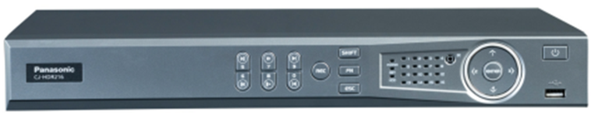

• Installation Guide ........................................... 1 pc.
• Screw …………………………………………… 2 pcs.
• Screw plug ……………………………………... 2 pcs.
- 16 CH with 1080p real time live view
- H.264 video encode
- 1/4/9/16 CH synchronous real time playback
- HDMI/ VGA simultaneous video output
- Support 2 SATA HDDs up to 12 TB, 2 USB
- Digital Zoom in Live & Playback
- iPhone, iPad & Android
Key Features

- Quick guide…………….……….. 1 pc
- Important safety instruction…….1 pc
- CD …………………………………1pc

Standard Accessories

Appearance

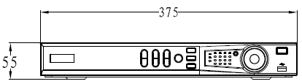
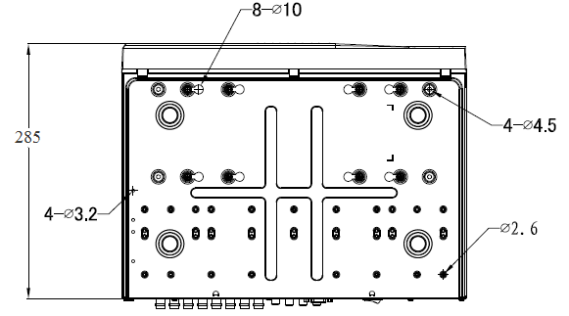
Important
- Safety Precaution: Carefully read the operating instruction manual before using this product.

DISTRIBUTED BY:
- All pictures are simulated.
- Weights and dimensions are approximate.
- Specifications are subject to change without notice.
- These products may be subject to export control regulations.
• Installation Guide ........................................... 1 pc.
• Screw …………………………………………… 2 pcs.
• Screw plug ……………………………………... 2 pcs.
• Installation Guide ........................................... 1 pc.
• Screw …………………………………………… 2 pcs.
• Screw plug ……………………………………... 2 pcs.
• Installation Guide ........................................... 1 pc.
• Screw …………………………………………… 2 pcs.
• Screw plug ……………………………………... 2 pcs.
• Installation Guide ........................................... 1 pc.
• Screw …………………………………………… 2 pcs.
• Screw plug ……………………………………... 2 pcs.
• Installation Guide ........................................... 1 pc.
• Screw …………………………………………… 2 pcs.
• Screw plug ……………………………………... 2 pcs.
• Installation Guide ........................................... 1 pc.
• Screw …………………………………………… 2 pcs.
• Screw plug ……………………………………... 2 pcs.
• Installation Guide ........................................... 1 pc.
• Screw …………………………………………… 2 pcs.
• Screw plug ……………………………………... 2 pcs.

